Center Light

📘 Definition
# Source: AI Source: Provided by: [Data Path: Persons Table -> ID Column: 1, Name_En Column: Motasem Essam] -> From: [ChatGPT] on [5/2/2026]
Center Light (sometimes called the light area or mid-light) is the bright region on an object where light hits it directly, but it is not as bright as the highlight.
It lies between the highlight (brightest spot) and the darker shaded areas.

💡 How center light appears
# Source: AI Source: Provided by: [Data Path: Persons Table -> ID Column: 1, Name_En Column: Motasem Essam] -> From: [ChatGPT] on [5/2/2026]
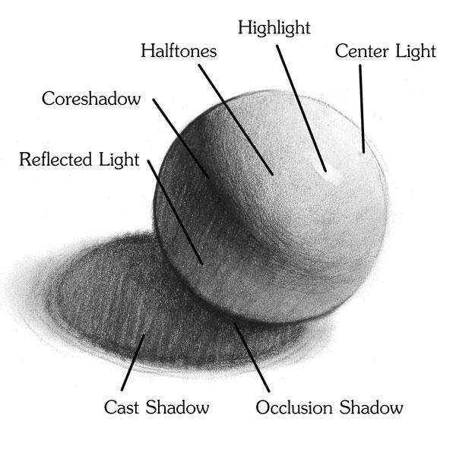
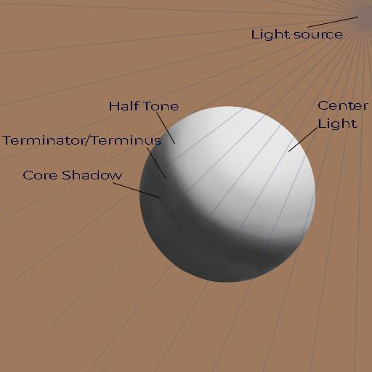
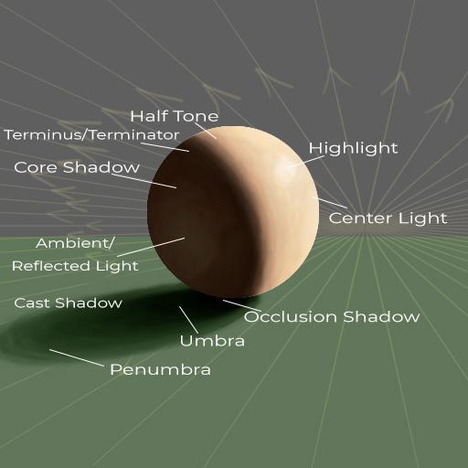
On a lit object, you can see:
- ✨ Highlight → brightest spot
- 💡 Center Light → main lighted area
- 🌗 Core Shadow → darker side
- 🌑 Cast Shadow → shadow on surface

🧠 Simple example
# Source: AI Source: Provided by: [Data Path: Persons Table -> ID Column: 1, Name_En Column: Motasem Essam] -> From: [ChatGPT] on [5/2/2026]
Think of a ball under a lamp:
- The small bright white spot → highlight
- The larger bright area around it → center light
- The darker side → shadow

🎨 Why it is important
# Source: AI Source: Provided by: [Data Path: Persons Table -> ID Column: 1, Name_En Column: Motasem Essam] -> From: [ChatGPT] on [5/2/2026]
- Helps show the main color of the object
- Makes objects look smooth and 3D
- Creates a natural transition from light to dark

⚙️ Key features
# Source: AI Source: Provided by: [Data Path: Persons Table -> ID Column: 1, Name_En Column: Motasem Essam] -> From: [ChatGPT] on [5/2/2026]
- 💡 Bright but not the brightest
- 📍 Located on the side facing the light
- 🎯 Shows the true color of the object
- 🔄 Connects highlight and shadow areas

🚀 In short:
# Source: AI Source: Provided by: [Data Path: Persons Table -> ID Column: 1, Name_En Column: Motasem Essam] -> From: [ChatGPT] on [5/2/2026]
Center Light = the main bright area on an object that receives direct light, but is less bright than the highlight.

